Khmer Angkor Keyboard

Contents

Overview 2

Khmer Angkor Keyboard Layouts 2

Desktop Layout –Windows/macOS 2

Touch Layout –Android/iOS 3

Khmer Character Categories and Keystrokes for Desktop 7

Consonants 7

Dependent Vowels 8

Signs 8

Independent Vowels 8

Diacritics 9

Native Punctuations 9

Latin Punctuations 9

Currencies 9

Khmer Numerals 9

Divination Lore 10

Khmer Lunar Dates 10

Discouraged/Obsolete characters 10

Characters used in minority languages 11

Joiners and Spaces 11

Typing in Khmer 11

Silent Auto-correction 11

Subscript + Vowel 12

Subscript + ្រ [U+17D2] [U+179A] 12

Subscript + Consonant Shifter + Vowel 12

Consonant Shifter + Vowel 12

Vowel with Nikahit [U+17C6] 12

Vowel ោ [U+17C4] and Vowel ើ [U+17BE] 12

Visually Identical Subscript 13

Vowel Rotation 13

Beep / Constraints 13

**Mistyped Characters** 14

# Overview

This documentation is adapted from three sources: ‘How to Type Khmer Unicode,’ ‘the Unicode Standard, Version 10.0.0’ and a paper authored by the Keyman team entitled ‘Spoof-Vulnerable Rendering in Khmer Unicode Implementation’ presented at Asia Conference on Information System in 2017. Customizations have been made by the Keyman team. A layer is added to both desktop layout in order to dedicate to the Khmer divination lore and Khmer lunar dates.

# Khmer Angkor Keyboard Layouts

## Desktop Layout –Windows/macOS

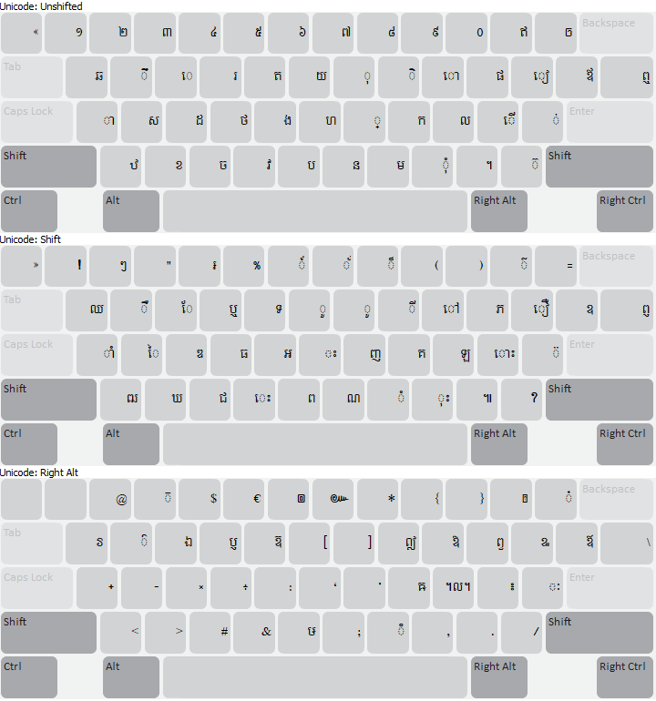

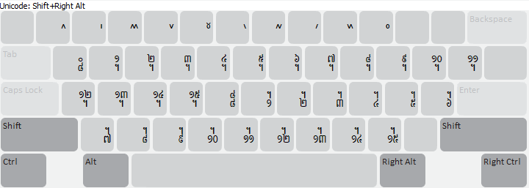

## 

## Touch Layout –Android/iOS

On a normal keyboard, one ought to select "្" and a consonant to get a ceong. For example, "្" + "ក" will output "្ក". But on this keyboard, "្" is​ no longer needed. Simply press and drag down (flick down) on any consonant key, and you will have the corresponding ceong. Using the flick gesture is much quicker than having to press twice to get a ceong of a consonant!

*Switching Layouts:*

This keyboard offers four layouts for your convenience: default, shift, Khmer numeric, and Arabic numeric.

* **Shift Layout**: press "⇧" to switch to the shift layout for more consonants and vowels.
* **Khmer Numeric Layout**: press "១២ឥ" to switch to the Khmer numeric layout for Khmer numerals and symbols.
* **Arabic Numeric Layout**: double-press "១២ឥ" to switch to the Arabic numeric layout for standard numbers and symbols.

To go to a certain layout, press the key as mentioned above. The key you press will turn blue meaning that you are currently on that layout. To return to the previous layout, press the key again.



**Phone - Default layout with flick gesture example on “ក” key**

This is the first layout that you will see after you installed the keyboard. It contains important consonants and vowels that are commonly used in Khmer texts. Look closely at the top right corner of each key, you will see a small indicator showing what a flick down will produce. This can be a ceong, a dependent vowel, or a symbol.

For example, flicking down on "ក" (ka) gives you "្ក" (ceong ka), while flicking down on "ិ" gives you "ី".



**Phone - Shift layout**

Similar to the Default layout, the Shift layout includes both consonants and vowels, but it also provides additional diacritics.

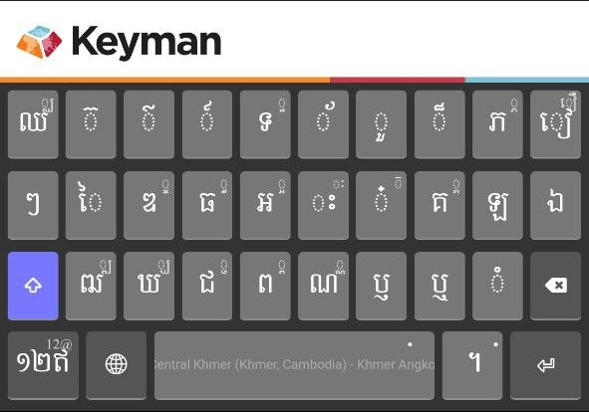

**Phone - Khmer Numeric layout**

This layout provides easy access to Khmer numerals, symbols, and independent vowels. For convenience, almost all independent vowels are grouped together on this layout.

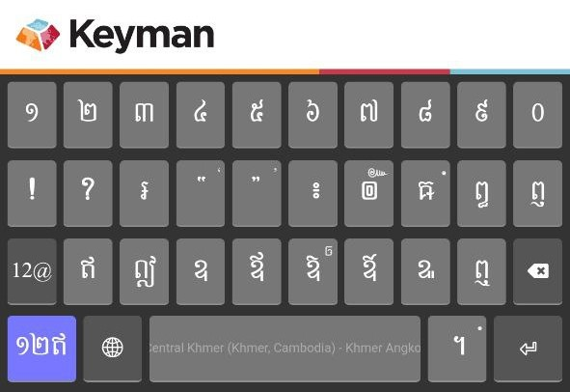

**Phone - Numeric layout**

This layout offers standard Arabic numbers and symbols for your convenience.

Keys with a small dot on the top right corner, indicating it has hidden keys. To access them, simply press and hold (long press) the key for a few seconds. More keys will appear with a selected key highlighted in blue. If that's not the key you need, slide your finger left or right to choose the desired key. To cancel the long press and hide the key menu, simply drag your finger away from the key and release it.



Available on mobile devices only, a feature called text prediction ([lexical model](https://help.keyman.com/developer/current-version/guides/lexical-models/intro/)) will be included with the Khmer Angkor keyboard. This feature enhances your ability to write Khmer text more easily and efficiently.

Example: “ខ្ញុំទៅសាលារៀន។”



Tablet - Default layout

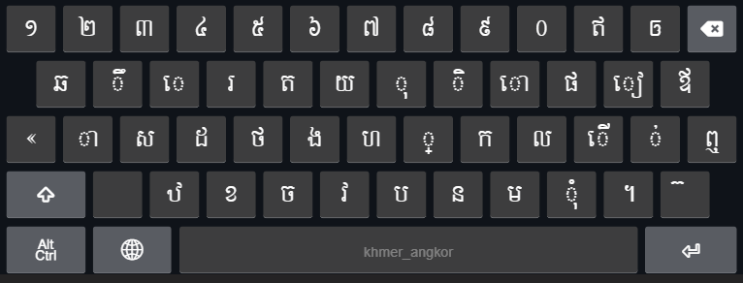

Tablet - Shift layout

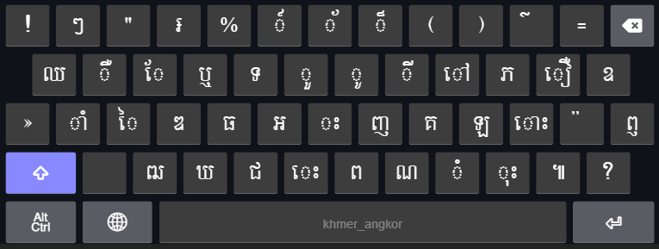

Tablet - AltGr layout

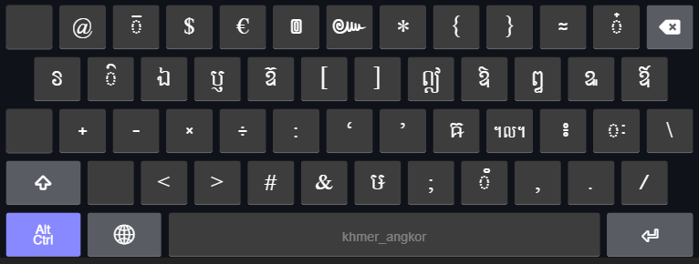

# Khmer Character Categories and Keystrokes for Desktop

## Consonants

|  |  |  |  |  |
| --- | --- | --- | --- | --- |
| **Consonant** | **Keystroke** |  | **Consonant** | **Keystroke** |
| ក [U+1780] | K | ថ [U+1790] | F |
| ខ [U+1781] | X | ទ [U+1791] | Shift T |
| គ [U+1782] | Shift K | ធ [U+1792] | Shift F |
| ឃ [U+1783] | Shift X | ន [U+1793] | N |
| ង [U+1784] | G | ប [U+1794] | B |
| ច [U+1785] | C | ផ [U+1795] | P |
| ឆ [U+1786] | Q | ព [U+1796] | Shift B |
| ជ [U+1787] | Shift C | ភ [U+1797] | Shift P |
| ឈ [U+1788] | Shift Q | ម [U+1798] | M |
| ញ [U+1789] | Shift J | យ [U+1799] | Y |
| ដ [U+178A] | D | រ [U+179A] | R |
| ឋ [U+178B] | Z | ល [U+179B] | L |
| ឌ [U+178C] | Shift D | វ [U+179C] | V |
| ឍ [U+178D] | Shift Z | ស [U+179F] | S |
| ណ [U+178E] | Shift N | ហ [U+17A0] | H |
| ត [U+178F] | T | ឡ [U+17A1] | Shift L |
|  |  | អ [U+17A2] | Shift G |

## Dependent Vowels

|  |  |  |  |  |
| --- | --- | --- | --- | --- |
| **Dependent Vowel** | **Keystroke** |  | **Dependent Vowel** | **Keystroke** |
| ា [U+17B6] | A | ៀ [U+17C0] | [ |
| ិ [U+17B7] | I | េ [U+17C1] | E |
| ី [U+17B8] | Shift I | ែ [U+17C2] | Shift E |
| ឹ [U+17B9] | W | ៃ [U+17C3] | Shift S |
| ឺ [U+17BA] | Shift W | ោ [U+17C4] | O |
| ុ [U+17BB] | U | ៅ [U+17C5] | Shift O |
| ូ [U+17BC] | Shift U | ុំ [U+17BB][U+17C6] | , |
| ួ [U+17BD] | Shift Y | ាំ [U+17B6][U+17C6] | Shift A |
| ើ [U+17BE] | ; | ុះ [U+17BB][U+17C7] | Shift , |
| ឿ [U+17BF] | Shift [ | េះ [U+17C1][U+17C7] | Shift V |
|  |  | ោះ [U+17C4][U+17C7] | Shift ; |

## Signs

|  |  |
| --- | --- |
| **Sign** | **Keystroke** |
| ំ [U+17C6] | Shift M |
| ះ [U+17C7] | Shift H |
| ៈ [U+17C8][1] | AltGr ’ |

## Independent Vowels

|  |  |  |  |  |
| --- | --- | --- | --- | --- |
| **Independent Vowel** | **Keystroke** |  | **Independent Vowel** | **Keystroke** |
| ឥ [U+17A5] | - | ឭ [U+17AD] | Shift \ |
| ឦ [U+17A6] | AltGr I | ឮ [U+17AE] | \ |
| ឧ [U+17A7] | Shift ] | ឯ [U+17AF] | AltGr E |
| ឩ [U+17A9] | AltGr [ | ឰ [U+17B0] | AltGr P |
| ឪ [U+17AA] | ] | ឱ [U+17B1] | AltGr O |
| ឫ [U+17AB] | AltGr R | ឲ [U+17B2] | = |
| ឬ [U+17AC] | Shift R | ឳ [U+17B3] | AltGr ] |

## Diacritics

|  |  |  |  |  |
| --- | --- | --- | --- | --- |
| **Diacritics** | **Keystroke** |  | **Diacritics** | **Keystroke** |
| ៉ [U+17C9] | Shift ’ | ៏ [U+17CF] | Shift 8 |
| ៊ [U+17CA] | / | ័ [U+17D0] | Shift 7 |
| ់ [U+17CB] | ’ | ៎ [U+17CE] | AltGr = |
| ៌ [U+17CC] | Shift - | ៓ [U+17D3] | AltGr M |
| ៍ [U+17CD] | Shift 6 | ្ [U+17D2] | J |

## Native Punctuations

|  |  |  |  |  |
| --- | --- | --- | --- | --- |
| **Native Punct.** | **Keystroke** |  | **Native Punct.** | **Keystroke** |
| ។ [U+17D4] | . | ៙ [U+17D9] | AltGr 6 |
| ៕ [U+17D5] | Shift . | ៚ [U+17DA] | AltGr 7 |
| ៖ [U+17D6] | AltGr ; | ៗ [U+17D7] | Shift 2 |

## Latin Punctuations

|  |  |  |  |  |
| --- | --- | --- | --- | --- |
| **Latin Punct.** | **Keystroke** |  | **Latin Punct.** | **Keystroke** |
| ! [U+0021] | Shift 1 | « [U+00AB] | ` |
| ? [U+003F] | Shift ? | » [U+00BB] | Shift ` |
| “ [U+0022] | Shift 3 | - [U+002D] | AltGr S |
| . [U+002E] | AltGr . | : [U+003A] | AltGr G |
| , [U+002C] | AltGr , | ‘ [U+2018] | AltGr H |
| ; [U+003B] | AltGr N | ’ [U+2019] | AltGr J |
| # [U+0023] | AltGr C |  | & [U+0026] | AltGr V |

## Currencies

|  |  |
| --- | --- |
| ៛ [U+17DB] | Shift 4 |

## Khmer Numerals

|  |  |  |  |  |
| --- | --- | --- | --- | --- |
| **Khmer Numeral** | **Keystroke** |  | **Khmer Numeral** | **Keystroke** |
| ១ [U+17E1] | 1 | ៦ [U+17E6] | 6 |
| ២ [U+17E2] | 2 | ៧ [U+17E7] | 7 |
| ៣ [U+17E3] | 3 | ៨ [U+17E8] | 8 |
| ៤ [U+17E4] | 4 | ៩ [U+17E9] | 9 |
| ៥ [U+17E5] | 5 | ០ [U+17E0] | 0 |

## Divination Lore

|  |  |  |  |  |
| --- | --- | --- | --- | --- |
| **Divination Lore** | **Keystroke** |  | **Divination Lore** | **Keystroke** |
| ៱ [U+17F1] | AltGr Shift 1 | ៶ [U+17F6] | AltGr Shift 6 |
| ៲ [U+17F2] | AltGr Shift 2 | ៷ [U+17F7] | AltGr Shift 7 |
| ៳ [U+17F3] | AltGr Shift 3 | ៸ [U+17F8] | AltGr Shift 8 |
| ៴ [U+17F4] | AltGr Shift 4 | ៹ [U+17F9] | AltGr Shift 9 |
| ៵ [U+17F5] | AltGr Shift 5 | ៰ [U+17F0] | AltGr Shift 0 |

## Khmer Lunar Dates

|  |  |  |  |  |
| --- | --- | --- | --- | --- |
| **Khmer Lunar Date** | **Keystroke** |  | **Khmer Lunar Date** | **Keystroke** |
| ᧠ [U+19E0] | AltGr Shift Q | ᧰ [U+19F0] | AltGr Shift G |
| ᧡ [U+19E1] | AltGr Shift W | ᧱ [U+19F1] | AltGr Shift H |
| ᧢ [U+19E2] | AltGr Shift E | ᧲ [U+19F2] | AltGr Shift J |
| ᧣ [U+19E3] | AltGr Shift R | ᧳ [U+19F3] | AltGr Shift K |
| ᧤ [U+19E4] | AltGr Shift T | ᧴ [U+19F4] | AltGr Shift L |
| ᧥ [U+19E5] | AltGr Shift Y | ᧵ [U+19F5] | AltGr Shift ; |
| ᧦ [U+19E6] | AltGr Shift U | ᧶ [U+19F6] | AltGr Shift ’ |
| ᧧ [U+19E7] | AltGr Shift I | ᧷ [U+19F7] | AltGr Shift Z |
| ᧨ [U+19E8] | AltGr Shift O | ᧸ [U+19F8] | AltGr Shift X |
| ᧩ [U+19E9] | AltGr Shift P | ᧹ [U+19F9] | AltGr Shift C |
| ᧪ [U+19EA] | AltGr Shift [ | ᧺ [U+19FA] | AltGr Shift V |
| ᧫ [U+19EB] | AltGr Shift ] | ᧻ [U+19FB] | AltGr Shift B |
| ᧬ [U+19EC] | AltGr Shift A | ᧼ [U+19FC] | AltGr Shift N |
| ᧭ [U+19ED] | AltGr Shift S | ᧽ [U+19FD] | AltGr Shift M |
| ᧮ [U+19EE] | AltGr Shift D | ᧾ [U+19FE] | AltGr Shift , |
| ᧯ [U+19EF] | AltGr Shift F | ᧿ [U+19FF] | AltGr Shift . |

## Discouraged/Obsolete characters

|  |  |
| --- | --- |
| **Character** | **Keystroke** |
| ៘ [U+17D8] | AltGr L |
| ឨ [U+17A8] | AltGr T |
| ៜ [U+17DC] | AltGr Q |
| ៑[2] [U+17D1] | AltGr 3 |
| ៓ [U+17D3] | AltGr M |

## Characters used in minority languages

|  |  |
| --- | --- |
| **Other Character** | **Keystroke** |
| ឝ [U+179D] | AltGr K |
| ឞ [U+179E] | AltGr B |
| ៝ [U+17DD] | AltGr W |

## Joiners and Spaces

|  |  |
| --- | --- |
| **Key name** | **Keystroke** |
| Zero-width non-joiner [U+200C] | AltGr + 1 |
| Zero-width joiner [U+200D] | AltGr + ‘ |
| Zero-width space [U+200B] | Spacebar |
| White space [U+0020] | Shift + Spacebar or Press spacebar twice |
| No break space [U+00A0] | AltGr + Spacebar |

# Typing in Khmer

Khmer Angkor keyboard adopted the key arrangement from that of Khmer NiDA keyboard. More functionalities have been added to it to assist in typing (i.e. reduce inconsistency in character sequences). Regardless of how the user may type, a well-formed word will be produced. Please note that only issues identified are covered. For how to install the Khmer Angkor keyboard, please click [here](https://help.keyman.com/products/desktop/9.0/docs/start_download-install_keyboard.php) for the instructions.

You can simply use Khmer Angkor as you would for any NiDA based keyboard. You may type a word in an order of how it is spelled, not how it appears to be, especially when the vowel is to the left of the consonant. For example, to type the word “តែ” which means ‘tea’, one should type the consonant first and then the vowel (i.e. press key “T” and then “Shift E”).

The order of characters is:

**Consonant + Subscript(s) + Consonant Shifter + Vowel + Diacritic**

## Silent Auto-correction

There are eight cases of invisible typos that Khmer Angkor keyboard automatically corrects. They could not be detected with the naked eye; and the rendering engines may render them all the same on the screen. The auto-correction involves reordering and/or transducing of certain in correct characters to the correct ones in a split second.

### Subscript + Vowel

When a subscript and a vowel occur together, the vowel has to come after the subscript. For instance, “ខ្មែរ” and “ខែ្មរ” look the same, but they are encoded differently.

1. ខ្មែរ = ខ ្ម ែ រ (correct)
2. ខែ្មរ = ខ ែ ្ម រ (incorrect)

Thanks to the context dependent rules, Khmer Angkor keyboard is able to output the second typing sequence the same as that of the first one.

### Subscript + ្រ [U+17D2] [U+179A]

According to the spelling rule, in a sequence of two subscript and one of which is ្រ [U+17D2] [U+179A], the ្រ [U+17D2] [U+179A] should come after another subscript.

* កញ្ជ្រឹល = ក ញ ្ជ ្រ ឹ ល (correct)
* កញ្រ្ជឹល = ក ញ ្រ ្ជ ឹ ល (incorrect)

As you can see the two-character sequences yield the same visual output on the screen. Once again, Khmer Angkor will be able to automatically swap the sequence of the second to the first; so that the output would be both looked and encoded correctly and consistently.

### Subscript + Consonant Shifter + Vowel

This is a case whereby the character sequence is vague in the Unicode Standard. Unicode Standard 4.0 and later have the consonant shifter come between the consonant and the subscript while Unicode Standard 3.0 has it after the subscript. Khmer Angkor conforms to Unicode 3.0 and it is taken as the standard sequence. If one typed a consonant shifter before a subscript, the order would be switched silently.

ម ៉ ្យ ា ង ⇒ ម ្យ ៉ ា ង

### Consonant Shifter + Vowel

Consonant shifters should be typed before a vowel. (See the same in the section above)

### Vowel with Nikahit [U+17C6]

Nikahit is considered as a sign in the Unicode Standard. However its function is more like that of a vowel. It is usually combined with another vowel, i.e. ុ [U+17BB] ា [U+17B6], and it should always be typed after these vowels.

ក ំ ុ ⇒ ក ុ ំ  
 ក ំ ា ⇒ ក ា ំ

### Vowel ោ [U+17C4] and Vowel ើ [U+17BE]

These two vowels could be mistakenly typed by adding ា [U+17B6] and េ [U+17C1] respectively to េ [U+17C1]. Given this sequence, Khmer Angkor would transform them to ោ [U+17C4] and ើ [U+17BE], the correct vowel encodings.

### Visually Identical Subscript

Two subscripts look exactly the same, but they are encoded with different Unicode code points, ្ដ [U+17D2][U+178A] and ្ត [U+17D2][U+178F]. According to the spelling rule, it governs that the first should come after ណ [U+178E] and the latter should come after ន [U+1793].

## Vowel Rotation

Since no two-vowel sequence is allowed, once one is typed after another, the vowel would switch to the one typed last. For example, if the current character is vowel ា [U+17B6], and then ែ [U+17C2] is typed, the final output would be ែ [U+17C2], not ា [U+17B6].

**NOTE**: The vowel rotation would not be triggered in the following cases:

* If the first vowel is េ [U+17C1] and the second is ី [U+17B8]​ or vice versa, then the switch would not happen, but the output would be ើ [U+17BE] instead.
* If the first vowel is េ [U+17C1] and the second is ា [U+17B8] or vice versa, then the switch would not happen, but the output would be ោ [U+17C4] instead.
* If the first vowel is on the above vowels[3] and the second is ុ [U+17BB] or vice versa, then the switch would not happen, but the output would be the corresponding consonant shifter instead. For examples: a sequence of ស ី ុ or ស ុ ី would be automated as ស៊ី (ស ៊ ី); ម ី ុ or ម ុ ី would be automated as ម៉ី (ម ៉ ី).
* When ុ [U+17BB] is typed after ាំ, it will be transformed to a consonant shifter corresponding with the consonant before ាំ before which the shifter will be placed. For example,
  + សាំ + ុ ⇒ ស៊ាំ (ស ៊ ាំ) and
  + មាំ + ុ ⇒ ម៉ាំ (ម ៉ ាំ).
* When ា or ុ is typed after ំ, the order will be reversed. For example,
  + ក + ំ + ុ ⇒ កុំ (ក ុ ំ) and
  + ក + ំ + ា ⇒ កាំ (ក ា ំ).

## Beep / Constraints

* No two consecutive vowels in a syllable.
* No Bantoc is allowed after a vowel, a pseudo vowel[4], a consonant shifter or a subscript.
* No two consecutive subscript signs (្) are allowed.
* No two consecutive consonant shifters are allowed.

## 

## **Mistyped Characters**

|  |  |  |
| --- | --- | --- |
| No | Mistyped as … | Transformed to … |
| 1 | ទ្ប (ទ ្ប) | ឡ |
| 2 | ប្ញ (ប ្ញ) | ឫ |
| 3 | ឫុ (ប ្ញ ុ) | ឬ |
| 4 | ឭា (ឭ ា) | ញ |
| 5 | ឮា (ឮ ា) | ញ |
| 6 | ព្ញ (ព ្ញ) | ឭ |
| 7 | ឭុ (ព ្ញ ុ) | ឮ |
| 8 | ព្ឋ (ព ្ឋ) | ឰ |
| 9 | ឧិ (ឧ ិ) | ឱ |
| 10 | ឧ៌ (ឧ ៌) | ឱ |
| 11 | ឧ៍ (ឧ ៍) | ឱ |
| 12 | ដ្ធ (ដ ្ធ) | ដ្ឋ |
| 13 | ទ្ឋ (ទ ្ឋ) | ទ្ធ |
| 14 | ពន្ឋ (ព ន ្ឋ) | ពន្ធ |
| 15 | ព័ន្ឋ (ព ័ ន ្ឋ) | ព័ន្ធ |
| 16 | ឪ្យ (ឪ ្យ) | ឱ្យ |
| 17 | ឳ្យ (ឳ ្យ) | ឱ្យ |
| 18 | ញ្វ (ញ ្វ) | ព្វា (ឧទា. សព្វារុធ) |
| 19 | េ ្យ ឺ | ឿ |
| 20 | េ ្យ ឹ | ឿ |
| 21 | េ ្យ ី | ឿ |

1. It is actually not a vowel, but it behaves like one. To some, this is a diacritics.
2. Note the different between this character and ៊ [U+17CA].
3. ិ [U+17B7], ី [U+17B8], ឹ [U+17B9], ឺ [U+17BA], ើ [U+17BE], and ាំ [U+17B6] [U+17C6] are considered as superscript vowels or above vowels.
4. Three characters play a role similar to that of vowels, thus they are called ‘pseudo vowel’.   
   They are: ំ [U+17C6], ះ [U+17C7], and ៈ [U+17C8].